**Configure and Connect a MySQL Database Instance with a Web**

**Server and Set up the Monitoring of the Solutions**

Step 1: Login to AWS Management Console. Go to VPC Service.

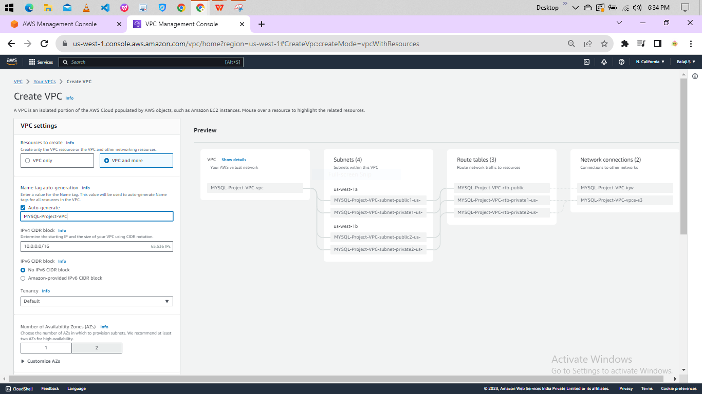

Step 2: Select none for VPC endpoint and click on create VPC.

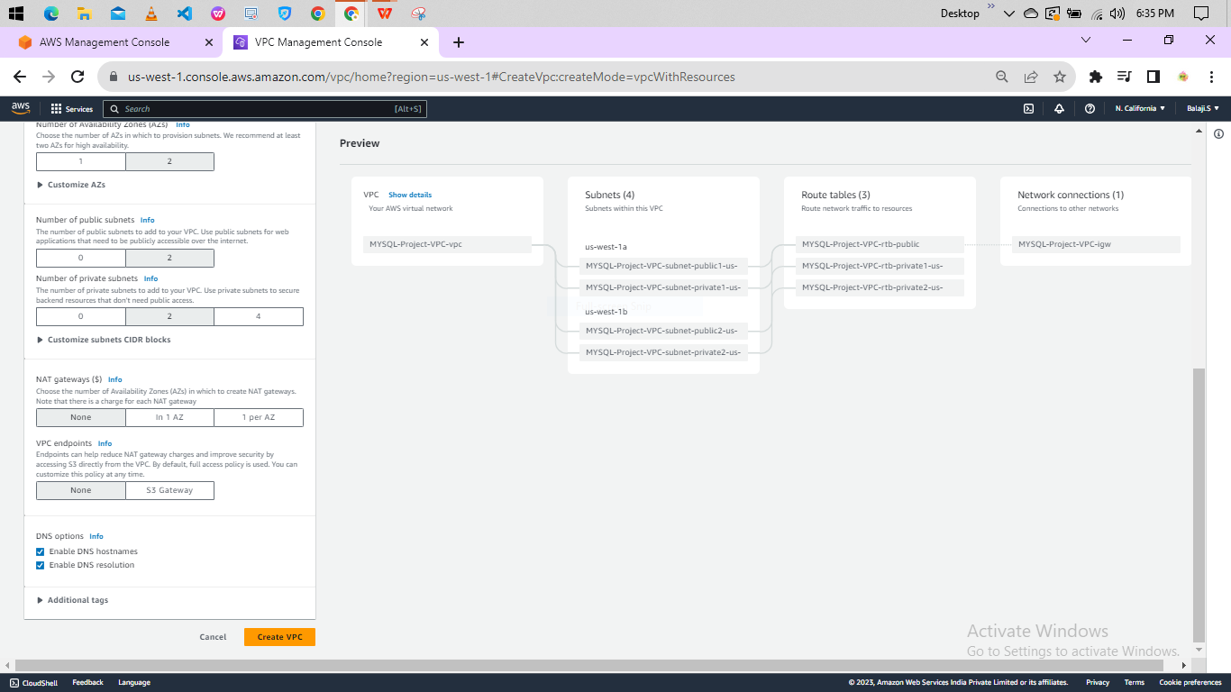

Step 3: Go to security Group and click on security group.

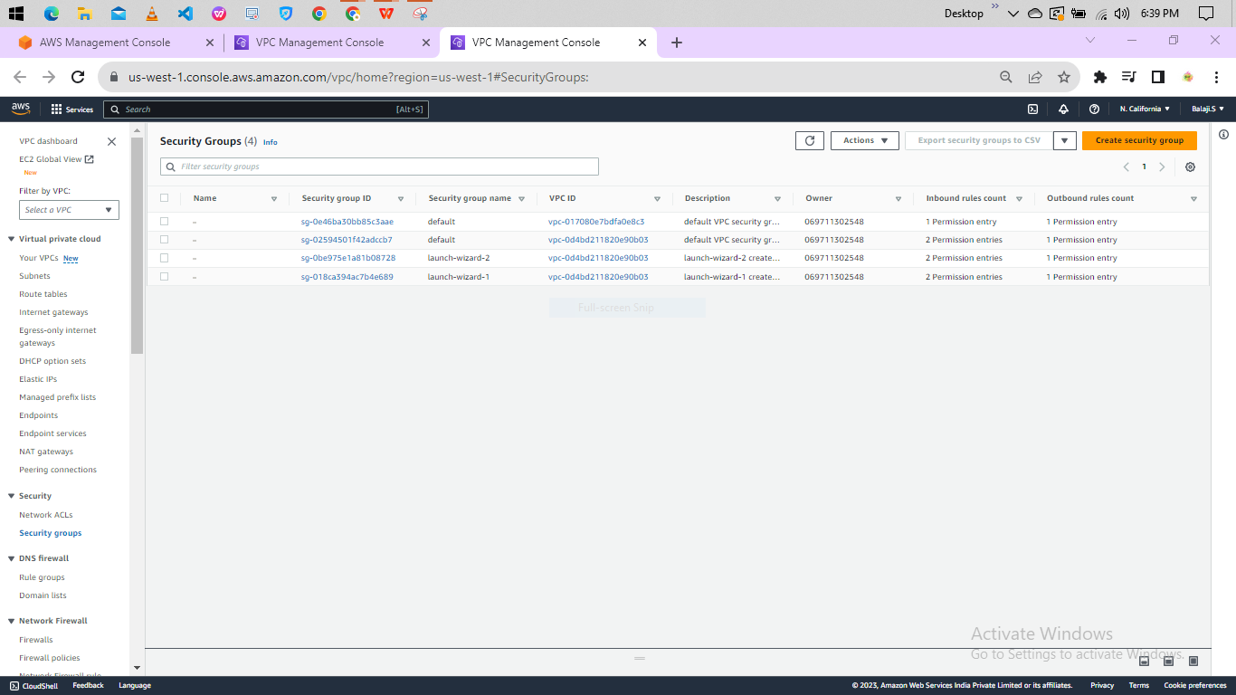

Step 4 : Enter Security group name,VPC and add inbound rules and click on create security group.

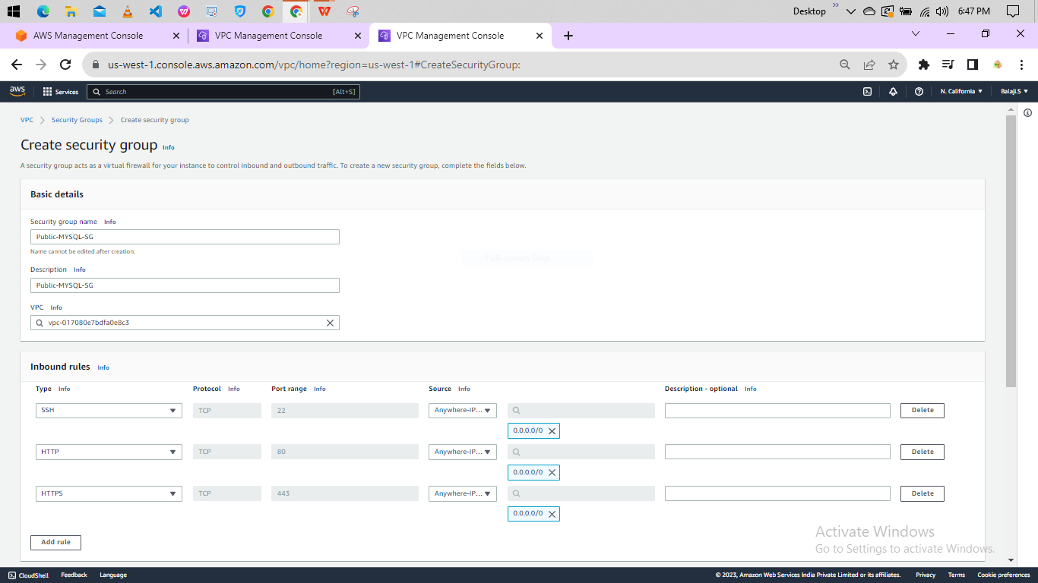

Step 5: create another Security group name,VPC and add inbound rules and click on create security group.

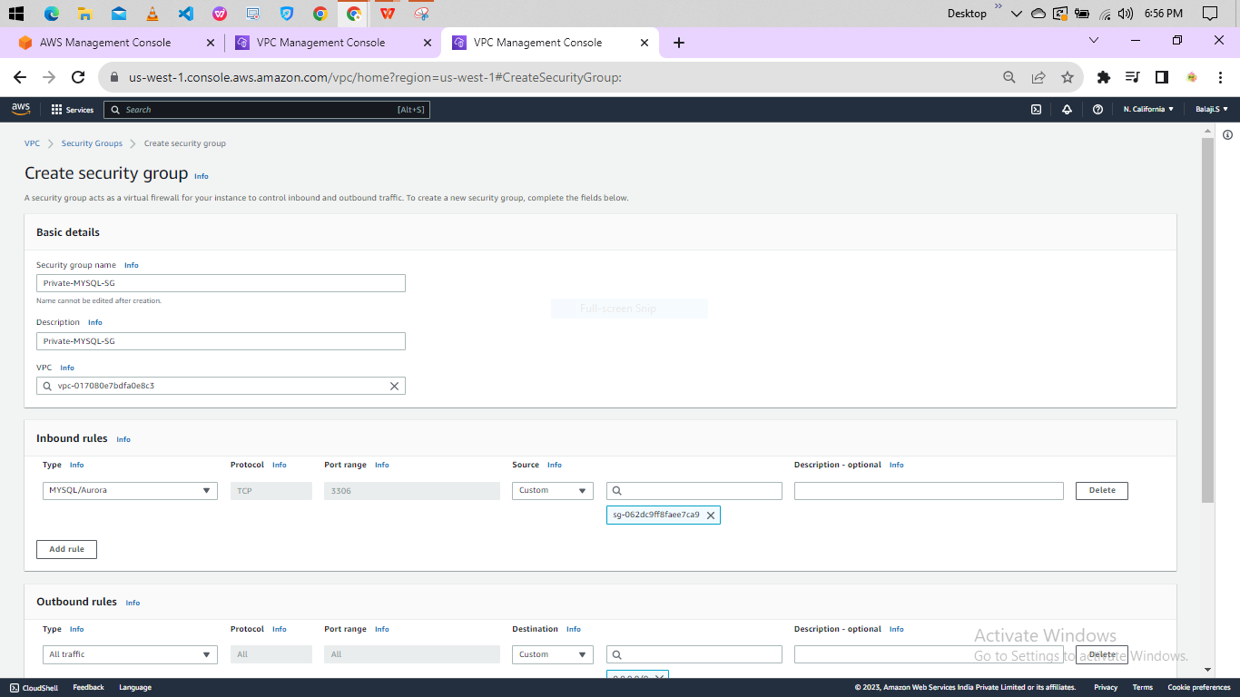

Step 6 : Go to RDS. Click on subnet Group.

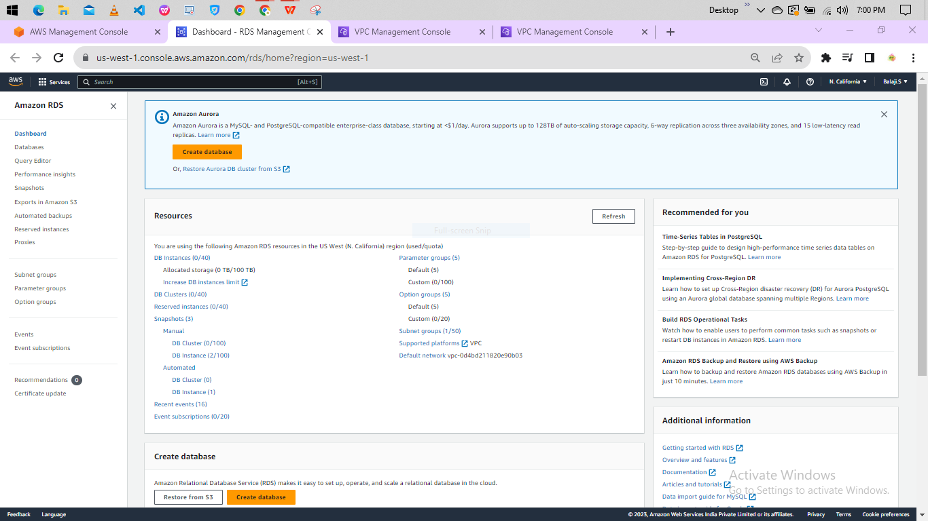

Step 7 : enter name,description,VPC and add subnets and click on create.

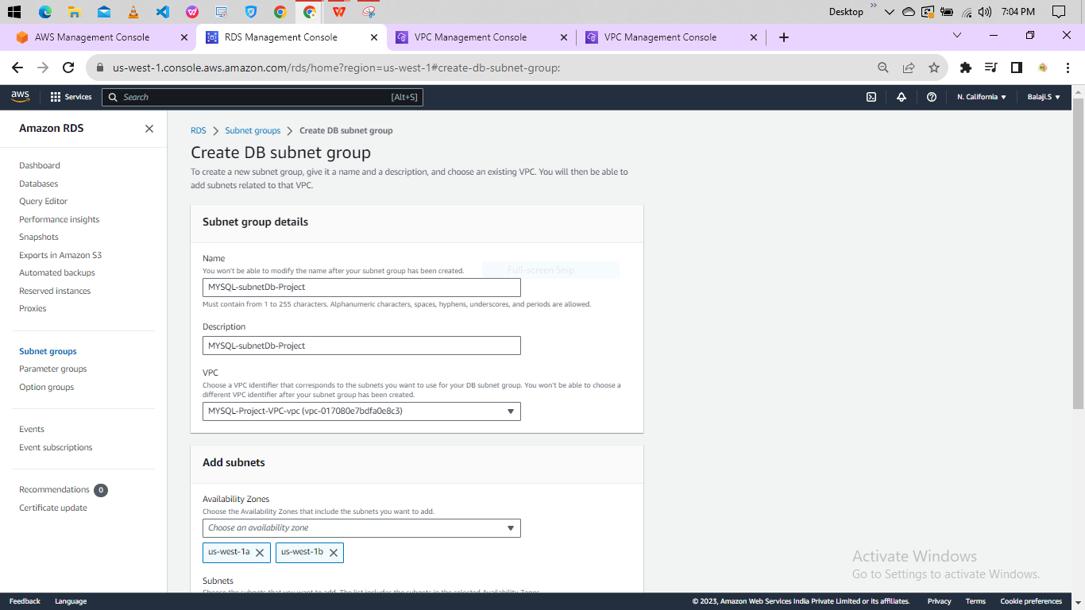

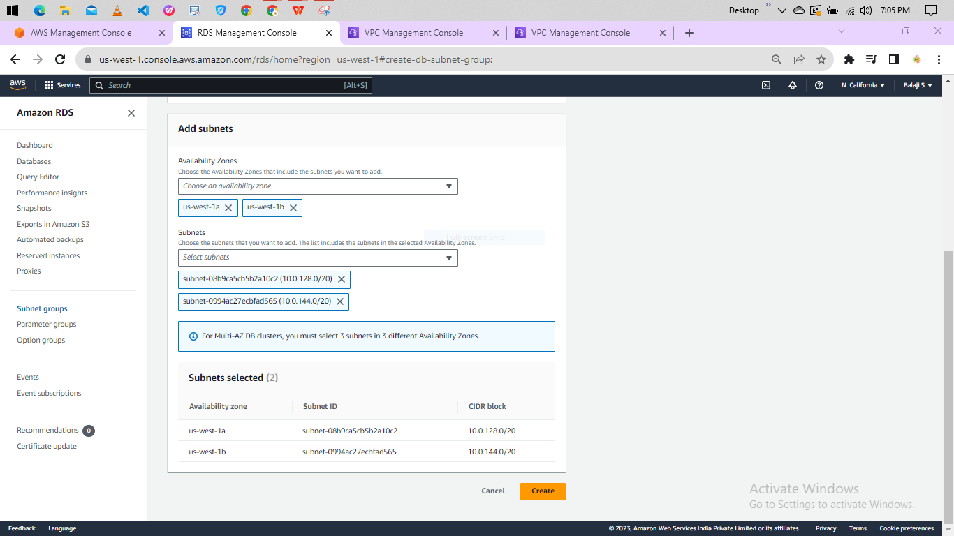

Step 8: Go to EC2 instance and launch the instance.

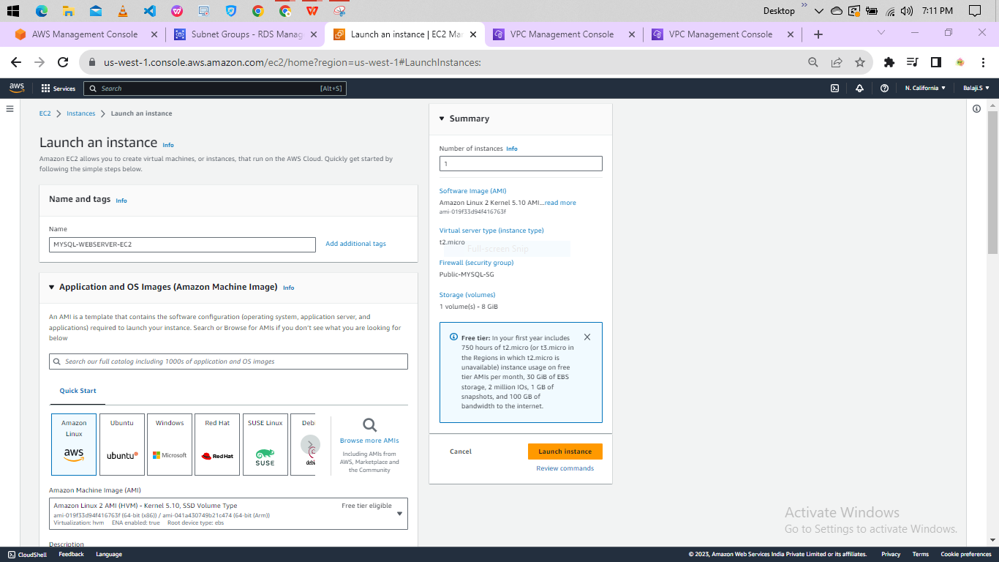

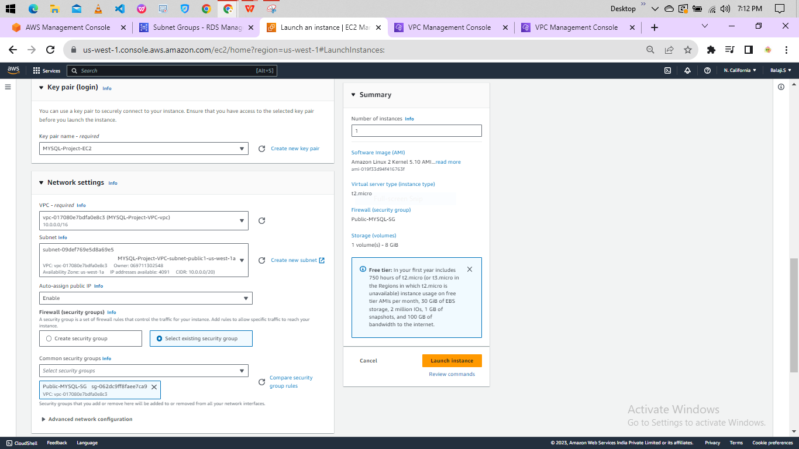

Step 9: Instance is created it is running click on connect.

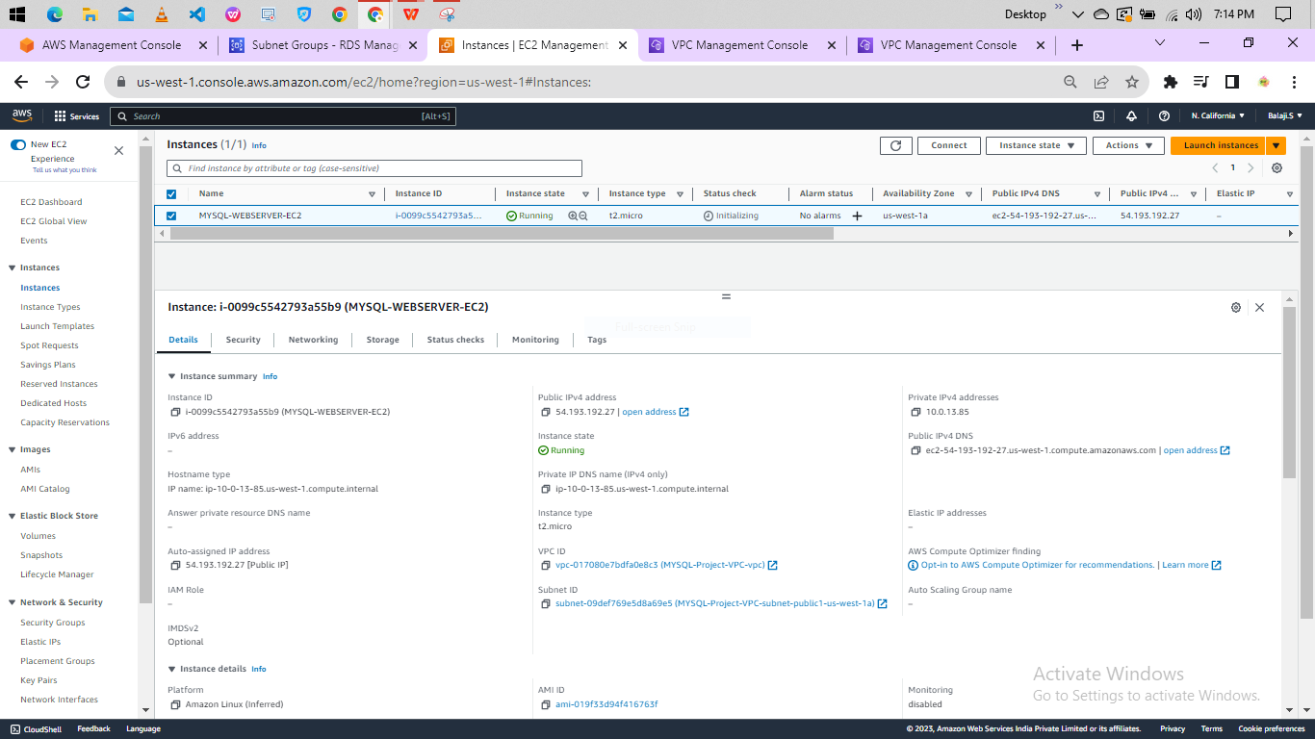

Step 10 : Click on Connect.

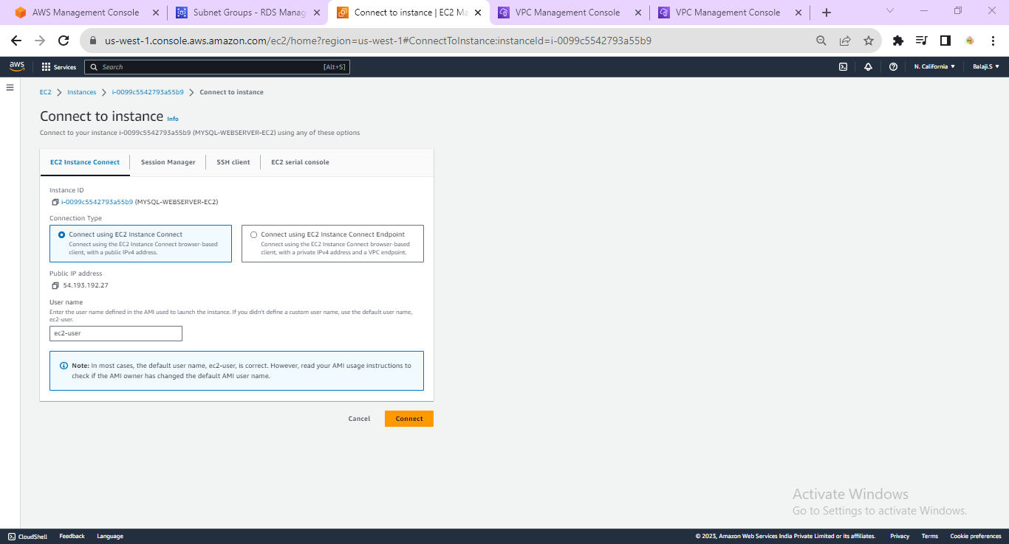

Step 11: It is connected to amazon linux -2.

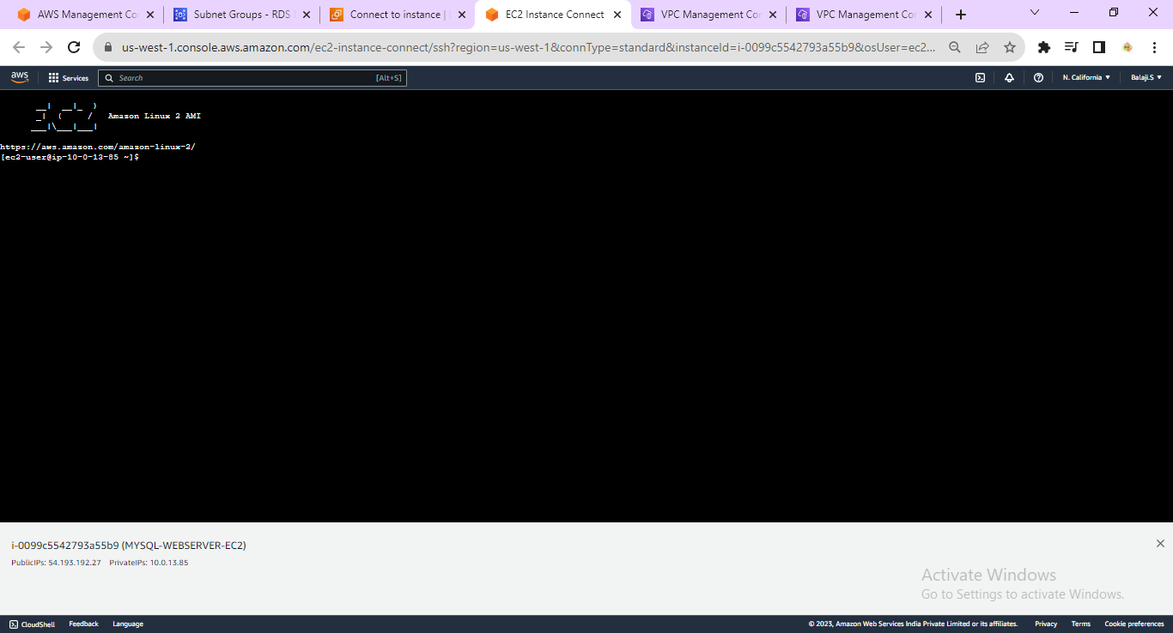

Step 12: Go to RDS Service and click on create database.

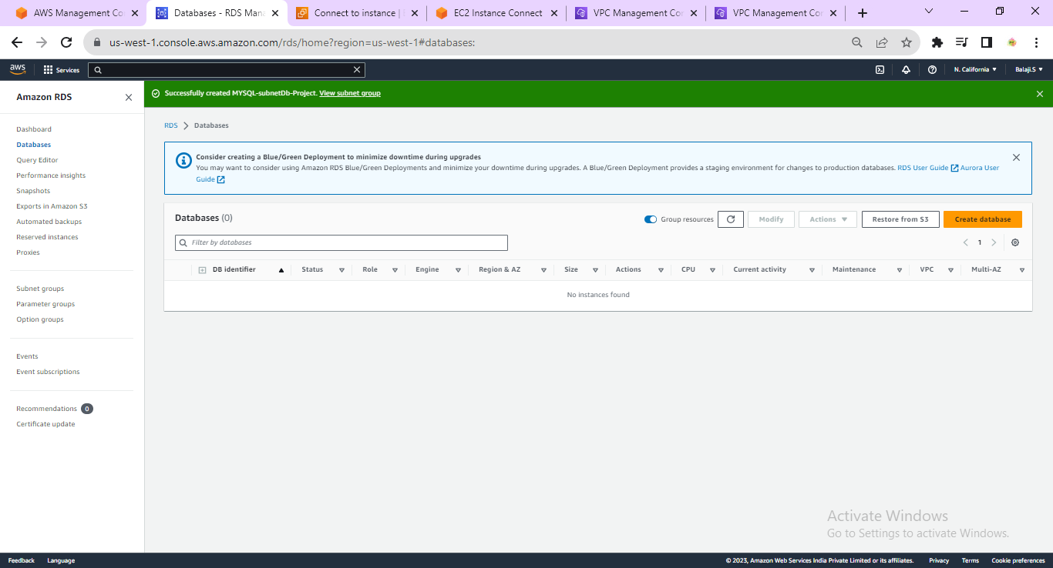

Step 13 : Select standard create and select engine options as mysql

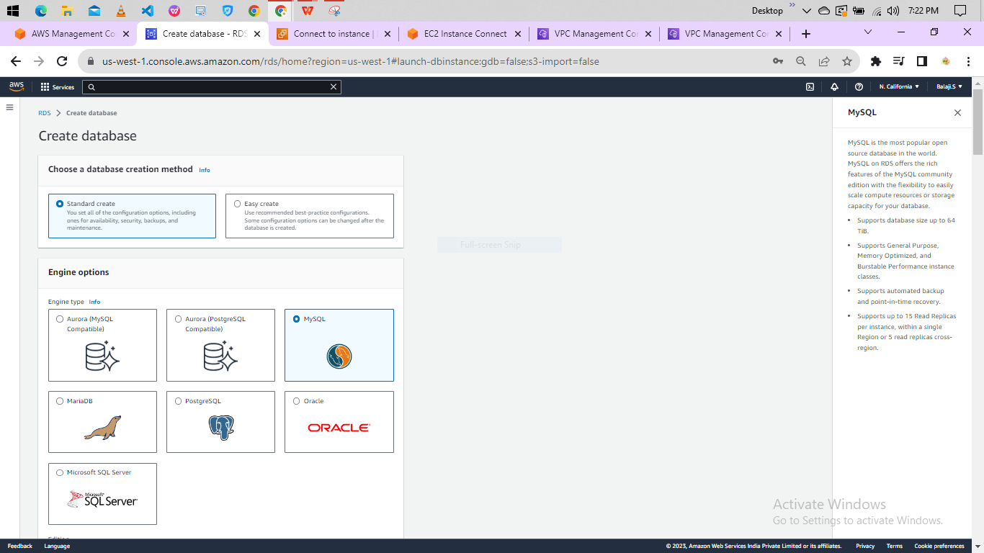

Step 14: select engine version,template as free-tier and enter DB instance identifier.

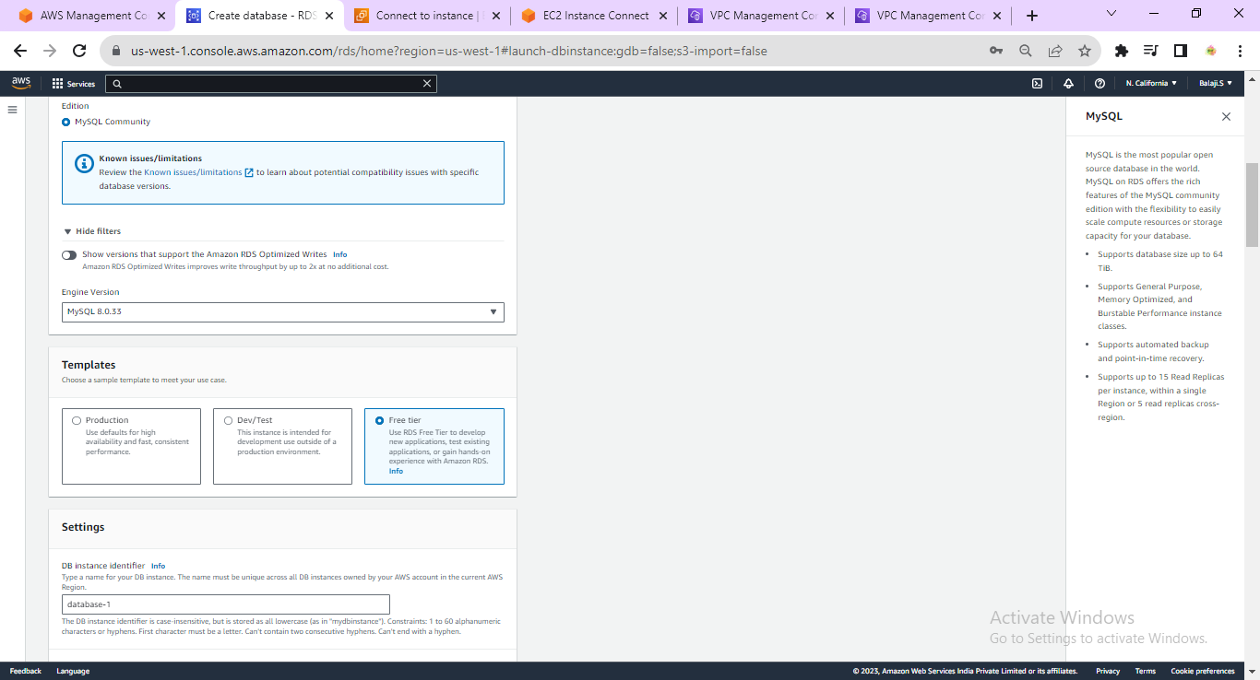

Step 15 : Enter master username,master password and confirm maser password.

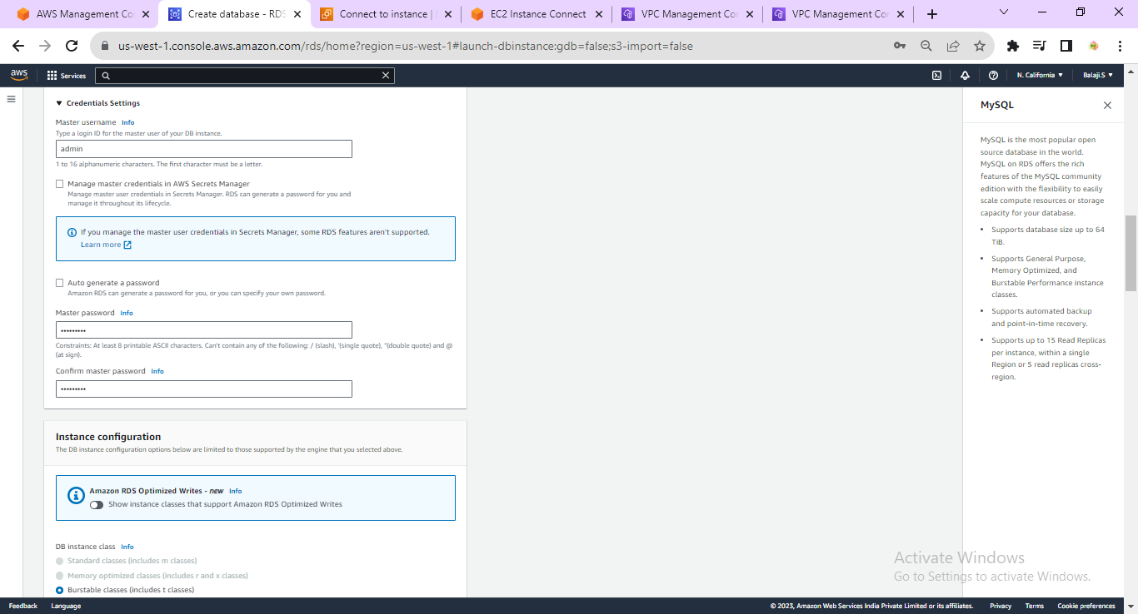

Step 16: Select VPC,DB subnet group,VPC Security group and click on create database and click on create database.

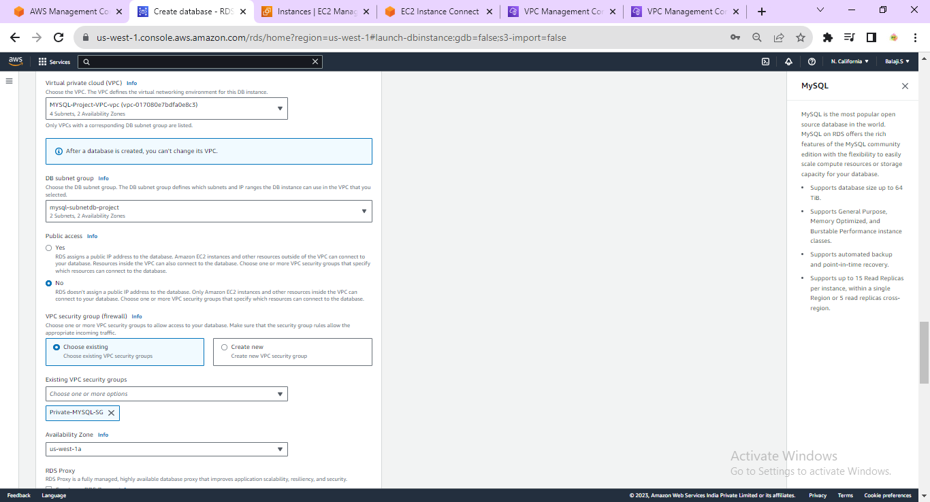

Step 17 : The status is creating wait for sometime to change status as available.

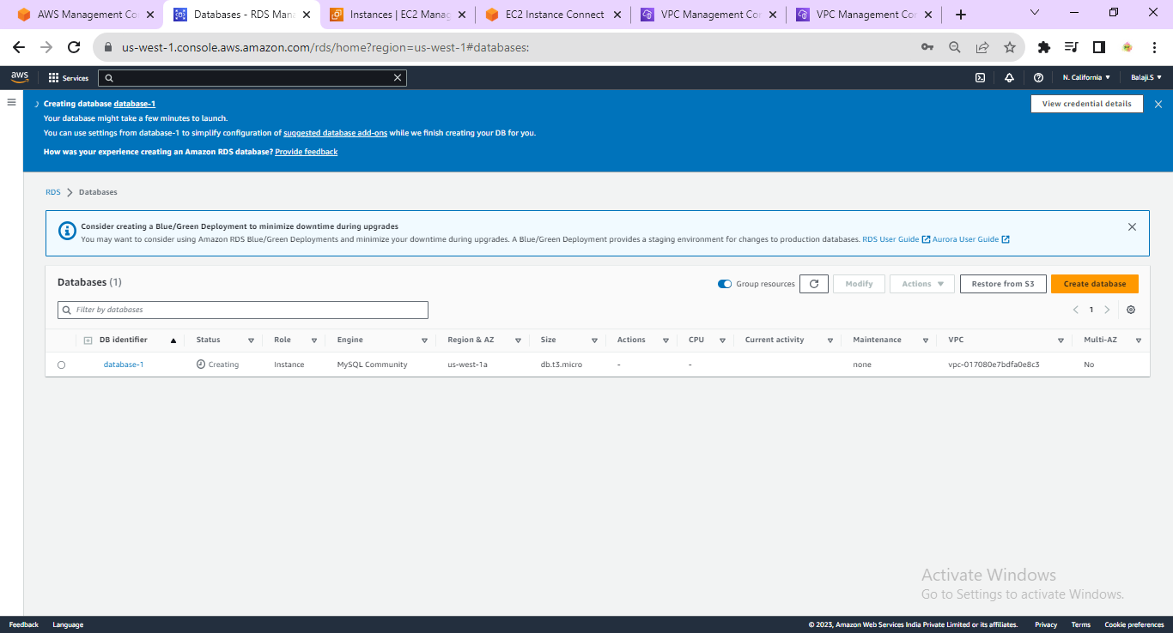

Step 19: Enter the below Commands in Linux machine.

~sudo yum update -y

~sudo amazon-linux-extras install php8.0 mariadb10.5

~sudo yum install -y httpd

~sudo systemctl start httpd

Step 20 : Copy the public IP address and paste in Browser.

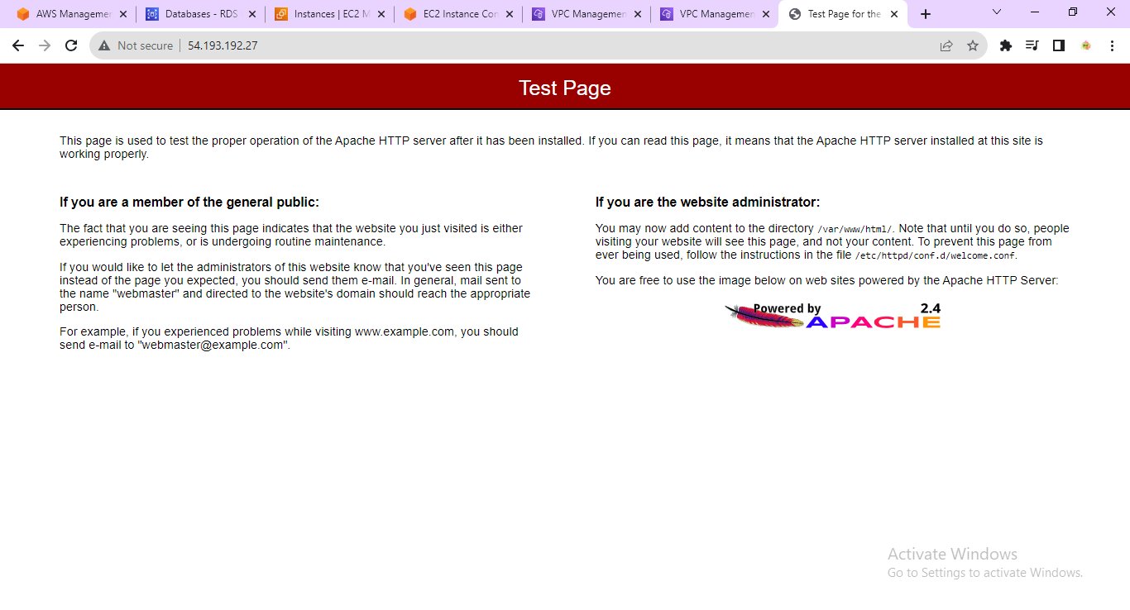

Step 21 : Enter these commands:

~sudo systemctl enable httpd

~sudo usermod -a -G apache ec2-user

~exit

Step 22 : Connect the Linux machine enter the below commands.

~groups

~sudo chown -R ec2-user:apache /var/www

~sudo chmod 2775 /var/www

~find /var/www -type d -exec sudo chmod 2775 {} \;

~find /var/www -type f -exec sudo chmod 0664 {} \;

~cd /var/www

~mkdir inc

~cd inc

~>dbinfo.inc

~nano dbinfo.inc

Step 23 : Paste the below php code. In DB_SERVER use RDS endpoint copy and paste it.

<?php

define('DB_SERVER', 'database-1.cjkfd1rdvllt.us-west-1.rds.amazonaws.com');

define('DB_USERNAME', 'admin');

define('DB_PASSWORD', 'password');

define('DB_DATABASE', 'sample');

?>

Step 24 : enter this command in Linux machine:

~cd /var/www/html

~>SamplePage.php

~nano SamplePage.php

